COURSE CODE: 24SDCS02 / 24SDCS02E / 24SDCS02P / 24SDCS02L FULL STACK APPLICATION DEVELOPMENT

M.PRAVEEN REDDY 2400032662

#SKILL - 7 ➔ REST API - CRUD Operations using ResponseEntity
Prerequisites:
- General Idea on Spring Boot MVC Architecture
- Knowledge of Service and Controller layers

A university application needs backend services to manage course details such as courseId, title, duration, and fee. The admin should be able to add, update, delete, and view course information. The system must return proper HTTP status codes and structured responses for reliable communication between client and server.

Your task is to implement REST endpoints using ResponseEntity to perform complete CRUD operations on course data.

Tasks:

- Create a Course entity with fields: courseId, title, duration, fee.
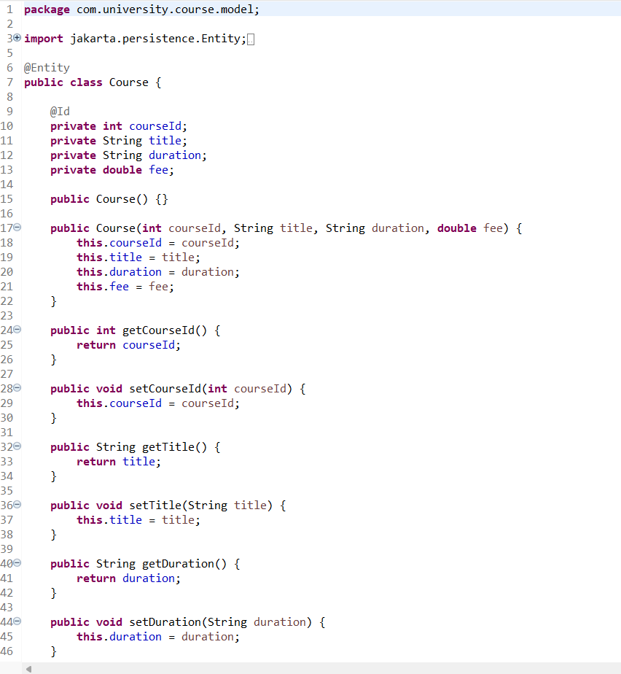
- Create a Service layer that performs full CRUD operations.
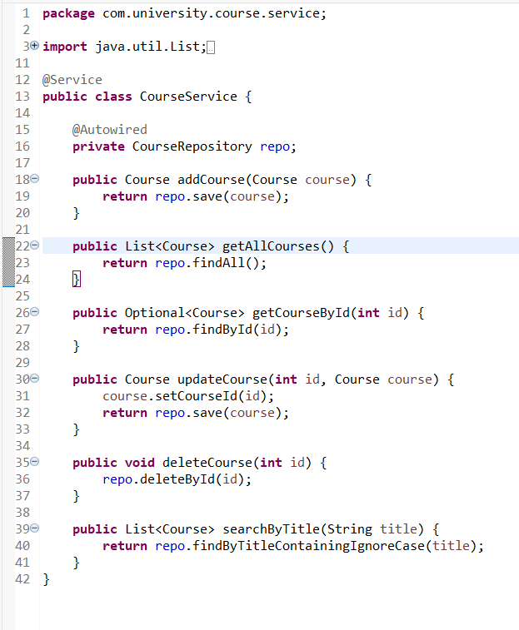
- Implement REST endpoints using @PostMapping, @PutMapping, @DeleteMapping, and @GetMapping.
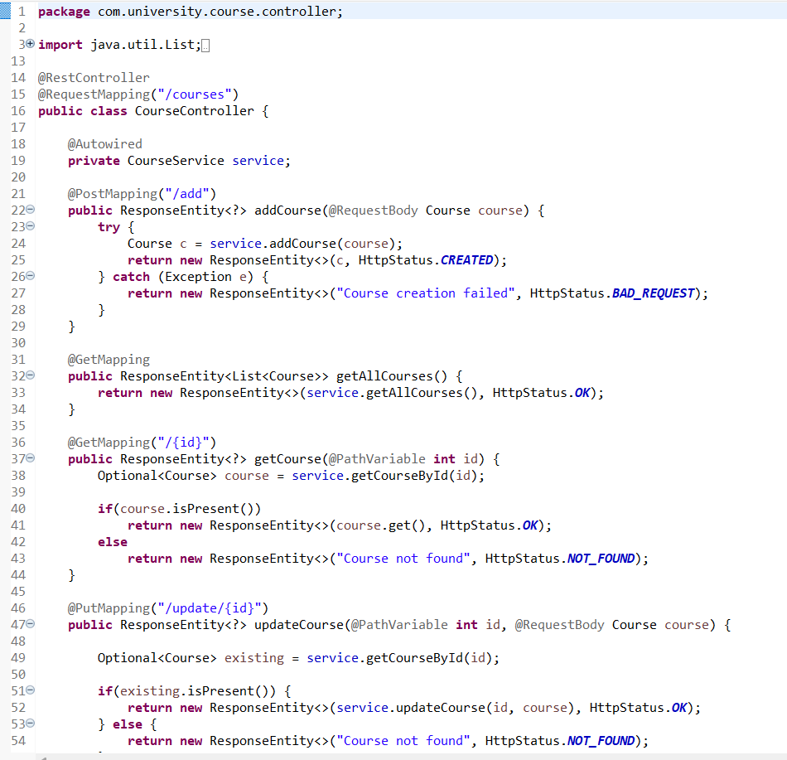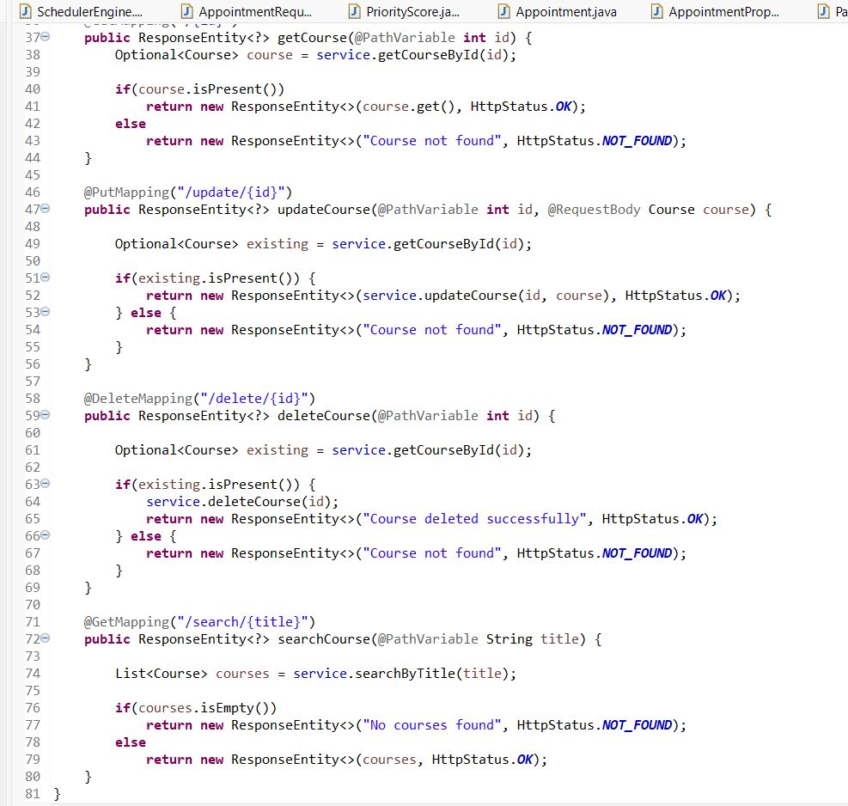
- Use ResponseEntity to return:
  - Success messages
  - Error messages
  - Status codes such as OK, CREATED, NOT_FOUND, BAD_REQUEST
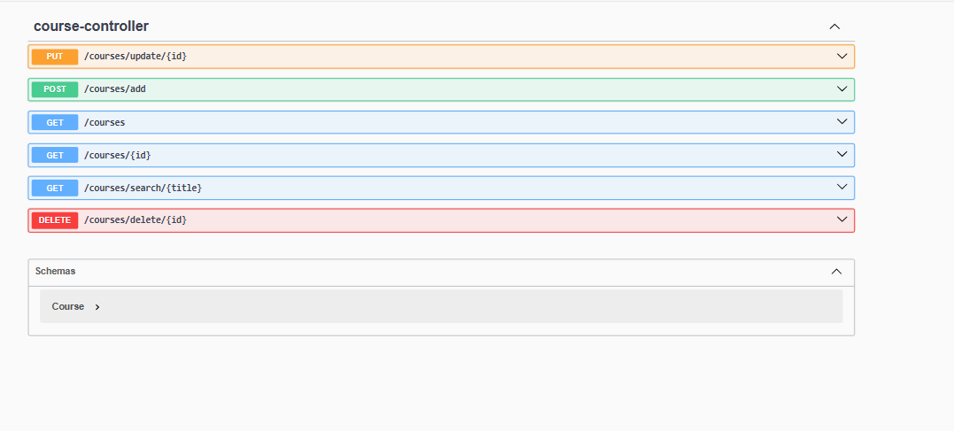
- Add a search endpoint /courses/search/{title} to filter courses by title.
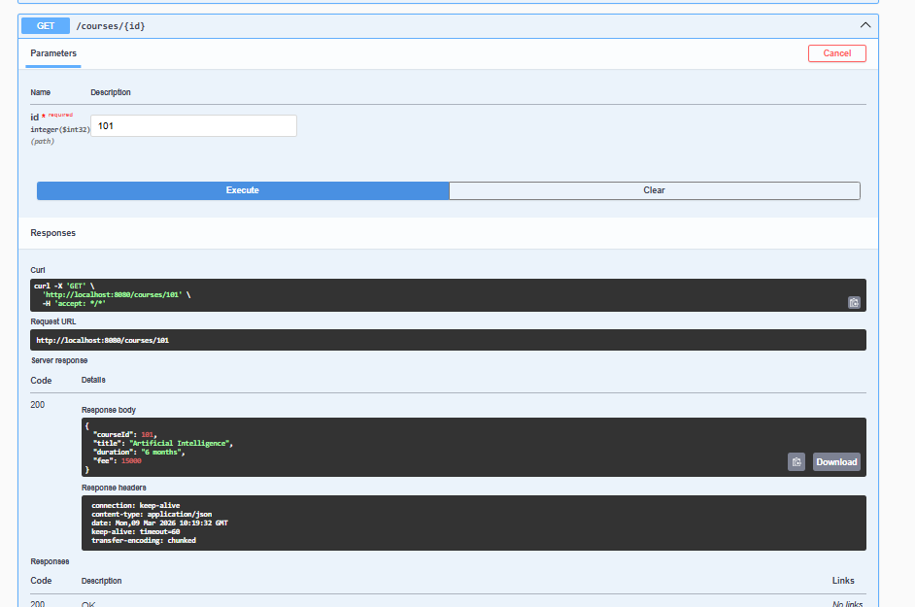
- Test all endpoints (valid and invalid cases) using Postman.
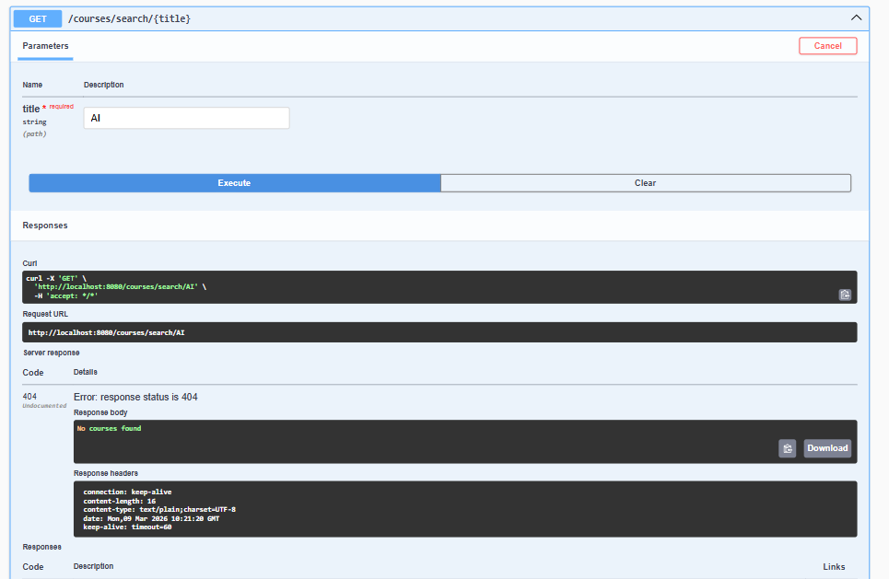
- Push the Spring Boot project to GitHub.
PraveenReddy-06/Full-Stack-Lab
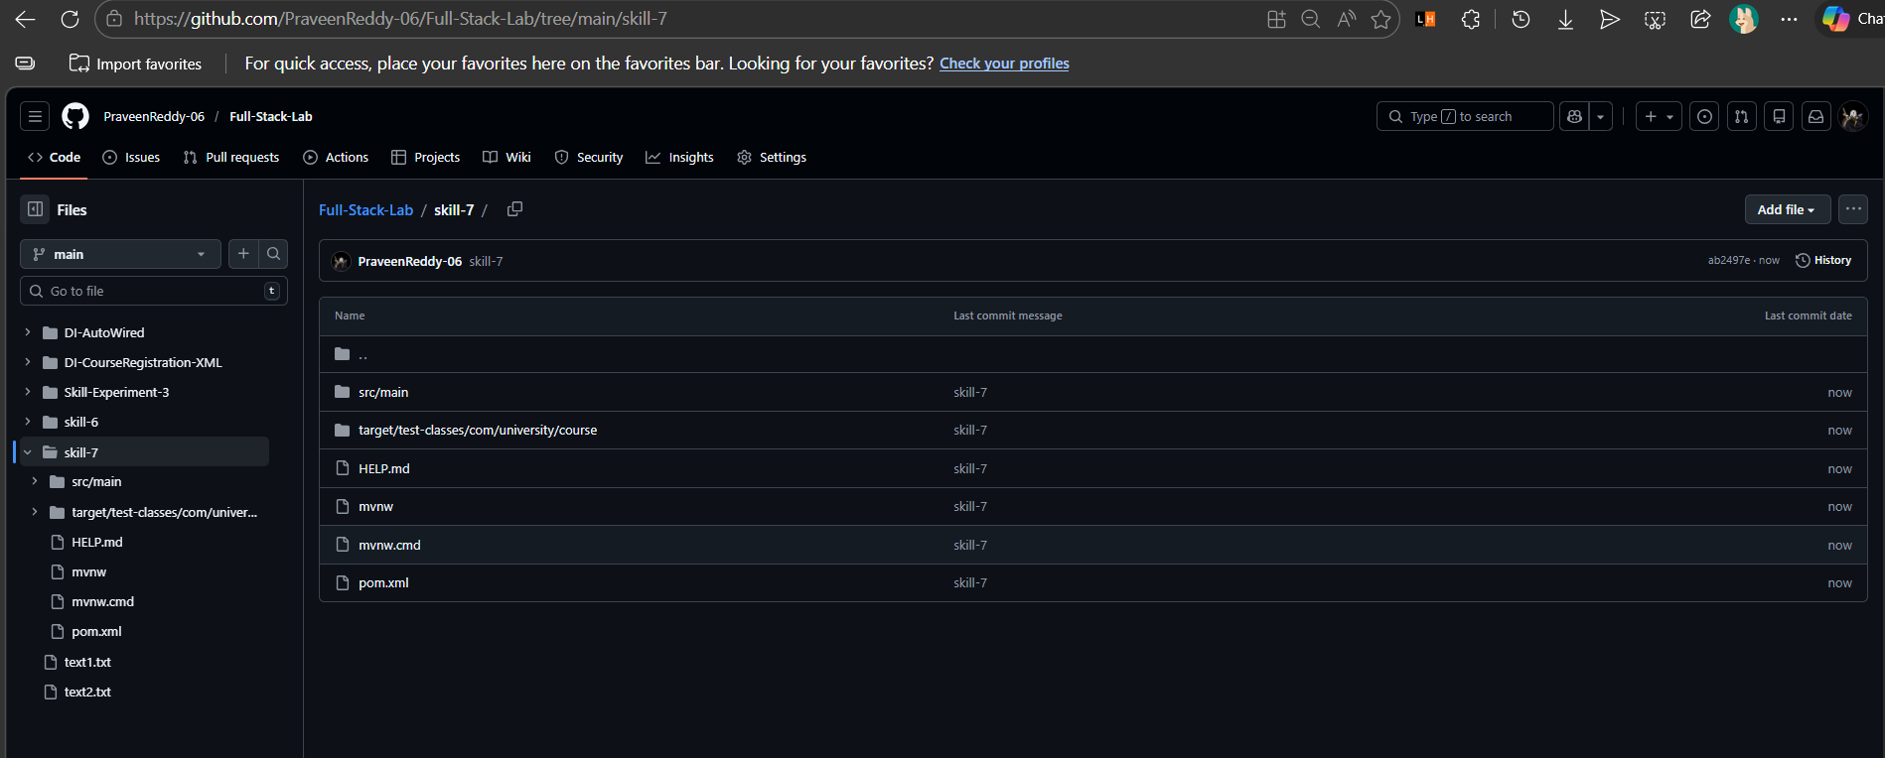

VIVA QUESTIONS:

- What is ResponseEntity used for?
ResponseEntity is used to control the entire HTTP response in a REST API, including the response body, HTTP status code, and headers.
- What is the difference between @PostMapping and @PutMapping?
@PostMapping is used to create new resources in the server.
@PutMapping is used to update an existing resource.
- Why are HTTP status codes important in REST APIs?
HTTP status codes inform the client about the result of the request, such as success (200 OK), resource created (201 CREATED), or error (404 NOT_FOUND).
- What happens if an invalid ID is passed to an endpoint?
The server typically returns a 404 NOT_FOUND status code with an error message indicating that the resource does not exist.
- Can ResponseEntity return both data and status codes together?
Yes. ResponseEntity can return response data (body) along with HTTP status codes and headers in the same response.

(For Evaluator’s use only)

Comment of the Evaluator (if Any)

Evaluator’s Observation
Marks Secured: out of
EMP ID & Full Name of the Evaluator:

Signature of the Evaluator Date of Evaluation:

